ANNEX 2: CITY SOLID WASTE ACTION PLAN (CSWAP)°
(As referred in Chapter 2 and 6)
ULB’s City Profile: (demographic and waste generation details)
1 | Name of ULB : | Aurangabad Municipal Corporation
2 | Name of the district: | Maharashtra
3 | No. of Municipal Zones in ULB | 9
4 | No. of wards in the ULB | 115
5 | Population & Households in the ULB as per 2011 Census:
  Population (P₀) | Households (HH₀)
  1175116 | 235,023
6 | Population & Households in the ULB as per Current scenario :
  Population (P1) | Households (HH₁)
  1,618,225 | 323645
7 | Projected population & Households in the ULB : 2025
  Population (P₂) | Households(HH₂)
  1,724,641 | 344928
8
  Institutional & Governance framework
   |  |  | Yes / No | If no, action to be taken to notify & timeline
  A | Regulatory Framework | Whether Municipal SWM Bylaws notified? ( conforming to SWM Rules 2016)( furnish details) | Yes, As per annexure (स्वमअ-2019/प्र.क्र.143/नवि-34 दि.13.02.2020
  A | Regulatory Framework | State SWM Strategy & Plan (available/ not available)
  B | Institutional Arrangement | Roles and Responsibilities for dealing with MSWM services. | Yes, As per annexure (स्वमअ-2019/प्र.क्र.143/नवि-34 दि.13.02.2020
  C | Governance Reforms - | Implementation of e-governance in ULBs (available / not available) | Yes
  D | ICT based Governance | ICT based monitoring of MSWM operations, services and complaint redressal (furnish details) | Yes | ICT based monitoring of segregation (31.11.2022)

9. | MSWM Service Level Benchmarks
   | Indicator | Benchmark | Before implementation of project(s) | After implementation of project(s)
  1 | Household level coverage of SWM services | 100% | 100% | 100%
  2 | Efficiency of collection of municipal solid  Waste | 100% | 100% | 100%
  3 | Extent of segregation of municipal solid waste | 100% | 80% | 100%
  4 | Extent of municipal solid waste recovered | 80% | 60% | 80%
  5 | Extent of scientific disposal of municipal  solid waste | 100% | 90% | 100%
  6 | Efficiency in redressal of customer complaints | 80% | 80% | 80%
  7 | Extent of cost recovery in SWM services | 100% | 80% | 100%
  8 | Efficiency in collection of SWM-related user charges | 90% | 40% | 90%
   | State SWM Strategy & Plan (available  / not available) | Available

Current MSW Management:
1 | Current MSW total generation in TPD (A): 450 TPD= Tonnes per day | Per Capita generation in gms: 278.08  (Ax10⁶ / P₁)
2 | Total waste collected (TPD) : 450
3 | No. of wards & % of wards practicing source segregation:
  No of wards | % of wards
  115 | 85 %
4 | No. of wards & % of wards practicing 100% door to door waste collection:
  No of wards | % of wards
  100% | 100%
5 | Total quantity transported in TPD to: Processing Plants :
  Processing Plant | SLF
  450 | Not available
6 | Secondary collection points/Transfer Stations (TS) (only if TS is/ are existing, otherwise not applicable)
  Waste stream | Number of TS | Capacity of TS (TPD)
  NA | NA | NA
7 | On basis of Waste Characterization, quantity of segregated waste generated (in TPD), of given waste streams
  MSW Waste Stream | Quantity in TPD | % of MSW
  Wet waste | 270 | 60%
  Dry waste | 160 | 35.55%
  Sanitary waste | 5 | 1.11%
  Domestic hazardous Waste | 1 | 0.22%
  Other waste (Drain Silt & Inert) | 18 | 4%
  C&D Waste | Qty inTPD | % of MSW
  Total C&D Waste generated | 80 | 17.77  (expressed as % of A at row 1 above
8 | Total quantity of MSW currently processed (B) in TPD: 350
9 | Total design capacity* available of all types of processing plants in TPD:430  *All existing, under construction, approved and defunct plants (defunct plants that have not been written off)  Note: This capacity will be equal to or greater than (B)
10 | Operation & Maintenance and Recovery of SWM fees Issues  Prepare statement of previous 5 years OEM costs incurred in ULB for OEM and the collections of SWM use fees and analyses for sustainability of O&M

Assessment of requirement of processing plants/facilities:
A | Projected waste generation@2025 in TPD:
  Per capita generation for calculating waste generation: 550 gms/capita
  ULBs > 10 lakh population@550 gms/capita:
  ULBs 1 lakh -10 lakh (both included) population@450gm/capita:
  ULBs <1 lakh population@300gm/capita:
B
  Projected Waste generation streams for year 2025: 948 TPD
  MSW Waste Stream | Fraction in MSW (Indicative –can be changed) | Projected waste generation | % of MSW
  Wet waste | 60% | 569 | 60%
  Dry waste | 35% | 337 | 35.55%
  Sanitary waste | Minor | 10.54 | 1.11%
  Domestic hazardous Waste | 10% | 2.1 | 0.22%
  Other waste (Drain Silt & Inert) | 20% | 38 | 4%

Other components of MSW Management
C | Sanitary Landfill (SLF) (Filling CELL for 5 years only)
  Waste sent to SLF restricted to 20% of total Municipal | 142.28
  SLF capacity for 5 years duly adding extra volume for daily cover, top cover etc. ( as per Manual on MSWM) Tonnes/cum/day | 337566
D | Estimated cost for proposed components as per GAP analysis
  Waste Management Component | Total proposed requirement (gap projected @ 2025) | Estimated cost / tonne (per machine for MRSs) | Proposed estimated cost
  Wet waste processing | 359.13 | 3600000 | 129,28,68,000
  Dry waste processing | 197.26 | 3300000 | 65,09,58,000
  C&D waste processing | 168.63 | 5,60,000 | 12,64,72,500
  Dumpsite Remediation | 12,35,294 | 550 | 67,94,11,700
  Sanitary landfill | 3,37,566 | 500 | 16,87,83,069
  Transfer Station | 948 | 16,00,000 | 151,68,00,000
  Mechanical Road Sweepers (MRSs) | 4 | 90,00,000 | 36,00,00,000
Financing Planning of Fund Required for Addressing the GAPs (Rs. in Crore)
 | Waste management Item | Total Proposed Cost | ACA under SBM-U 2.0 | State Govt. Fund | ULB fund | Other Fund (PPP, Others)
1 | For wet waste processing | 1292868000 | 323217000 | 206858880 | 762792120
2 | For Dry waste processing | 650958000 | 162739500 | 104153280 | 384065220
3 | For C&D waste processing | 94432800 | 23608200 | 15109248 | 55715352
4 | For Dumpsite Remediation | 67,94,11,700 | 169852925 | 108705872 | 400852903
5 | For Sanitary landfill | 168783069 | 42195767 | 27005291 | 99582011
5 | For Transfer Station | 1516800000 | 379200000 | 242688000 | 894912000
6 | For Mechanical Road Sweepers | 36000000 | 9000000 | 5760000 | 21240000
 | Grand Total | 4439253569 | 1109813392 | 710280571 | 2619159606

Module 1: MSW Processing GAP analysis & Action Plan
M 1.1 GAP Assessment for 100% Processing of MSW at ULB level

Processing Facility proposals | Existing Plants Capacity  (TPD) | Status of Current Capacity- Deficit/ Surplus | GAP  Projected @2025 (TPD)
Mixed Waste Processing Facility (continue to be used for either Wet OR Dry Waste) — Data taken for assessing capacities |  |  | No new mixed waste plant will be allowed
Composting Plants (for WET waste) | 210 | -60 | 359.13
Bio-methanation Plants (for WET waste) | 30 | 0 | 0
Material Recovery Facilities MRF— (for DRY waste) | 160 | -20 | 197.26
Standalone RDF Plants (for DRY waste downstream of MRFs)(not part of composting plants) | 20 | 0 | 0
Waste to Electricity (RDF based — only for ULBs > 10 lakh) | - | - | -
Others (describe the nature of plants, feed stock should be source segregated waste) | - | - | -
*(Operational/Under Constn. / in Tender Process, Non-Functional good condition )

Explanation for calculating the GAP.

Many ULB5 have installed composting plants receiving mass waste, without segregation at source, but carry out segregation within the process. Such plants shall continue to be utilized for either wet or dry waste, for full design capacity with segregation at source. It will result in proposing plants for other waste stream only.
Additional process may be added down the line to process RDF if not already being done in such plants.

After the GAP analysis, actions need to be taken for preparation of DPRs Identifying & earmarking land; documents for tenders etc.

M 1.2 ULB level Action Plan for achieving 100% scientific MSW Processing

Processing Facility proposals | Proposed Plant Capacity (TPD) | Estimated Cost | Plant Commissioning Date
Composting Plants (for WET waste) | 359.13 | 129,28,68,000 | 31/09/2023
Bio-methanation Plants (for WET waste) | - | -
Material Recovery Facilities MRF— (for DRY waste) | 197.26 | 65,09,58,000 | 31/12/2023
Standalone RDF Plants (for DRY waste downstream of MRFs)(not part of composting plants) | - | -
Waste to Electricity (RDF based — only for ULBs > 10 lakh) | - | -
Others (describe the nature of plants
-feed stock should be source segregated waste)
TOTAL
Other Proposals part of MSW  Construction of SLF | 337566 | 16,87,83,069 | 31/01/2023
Construction of TS, if required  (ULBs >5lakh and haulage of fully load- ed vehicles is > 15Km | 948 | 151,68,00,000 | 31/02/2023

M 1.3 ULB commitment timelines for Certification under Garbage-free Cities Star Rating

S.No | GFC Star Rating Certification | Committed Date
1 | 1-Star GFC Rating Certification | 31/08/2022
2 | 3-Star GFC Rating Certification | (mandatory before 31.3.2026)
3 | 5-Star GFC Rating Certification | These Certifications are beyond the mandatory requirement under SBM 2.0. ULBs are encouraged to get these certifi- cations.
4 | 7-Star GFC Rating Certification

M 1.4 State/ UT - Consolidated Financial Action Plan for MSW Processing: Financials in Rs. Crore
 | FY 2021-22 | FY 2022-23 | FY 2023-24 | TOTAL  (equal to SBM 2.O SWM allocation, Processing part only)
Action Plan Amount |  | 1166295600 | 777530400
No. of ULBs covered* |  |  |  | All ULBs in the State/ UT covered in APs by 2023-24
* Detailed ULB-wise, plant-wise Action Plan statement is to be furnished Action Plan approvals to be obtained by 31.3.2024 for all ULBS

M 1.5 State / UT — Consolidated Certification- cum-Implementation Action Plan (only First time GFC Certifications to be considered)

Certification | Before SBM 2.O | FY  2021-22 | FY  2022-23 | FY  2023-24 | FY  2024-25 | FY  2025-26
No. of ULBs rated l—Star |  |  |  | All ULBs to be l-Star rated by 31.3.2023
No. of ULBs
rated 3—Star*
No. of ULBs with 100% waste processing |  | Institutional Arrangement
* All ULBs to become 3-Star GFC Rated before 31.3.2026

Module 2: Legacy Waste Dumpsites Remediation Action Plan
M2.1 ULB’s Dumpsite Remediation Plan (applicable only if ULB has an existing dumpsite(s))
Total quantity of existing legacy waste in tonnes | 12,35,294
Land occupied by the dumpsite, Acres | 44
Proposed method for remediation* | Biomining
Action plan for recoverable material | RDF, Fill low area
Indicative Uses/ Utilization of Segregated Material | Forward to Recycling plants
Land to be recovered, Acres (extent of land from which waste is completely removed) | 32
End uses of remediated dumpsite area | Garden
Estimated Cost for Remediation | 67,94,11,700
Most likely date for complete remediation ( not beyond 31.3.2023 for  ULBs < 10 lakhs and 31.3.2024 for ULBs > 10 lakhs) | 31-03-2024
* to be compliant irith extant NGT and Court orders

M2.2 State/ UT— Consolidated Financial Action Plan for Dumpsite Remediation:
Financials in Rs. Crore

 | FY 2021-22 | FY 2022-23 | TOTAL (equal to SBM 2.O allocation for dumpsite remediation for the State / UT)
Action Plan Amount | - | 67.94 Cr. | 67.94 Cr.
No. of ULBs covered* |  |  | all ULBs in the State/ UT
Action Plan approvals to be obtained by 31.3.2022 for all ULBs <10 Lakh and by 31.3.2023 for all ULBs >10 lakh
* Detailed ULB-wise, dumpsite-wise Action Plan statement is to be furnished

M2.3 State/ UT - Consolidated Dumpsite Remediation Implementation Action Plan

Remediation | Before SBM 2.O | By 31.7.2022 | By 31.3 2023 | By 31.3.2024 | TOTAL
No. of ULBs completing remediation | 0% | 15% | 60% | 100% | to complete remediation by 31.3.2024

Module 3: CAD Waste Processing Action Plan (only for 154
non-complying (NCAP cities) and 5-lakh size ULBs)

M3.1 ULBs Gap Assessment for Processing of Construction and Demolition Waste
(Applicable for ULBs > 5 lakh population and/or 154 Non-attainment cities)

Estimated C&D Waste generated @ 50gm/capita of total Municipal Solid Waste in TPD | 86.23
Add 25% extra for bulk C & D waste generators,  depositing with ULB | 20.23
Add 20% over and above | 121.37
Total CAD waste currently generated in TPD | 101.14
Existing capacity of C&D waste processing plant available in TPD | 00
Proposed capacity in TPD for 2025 | 146.59

M3.2 State/ UT - Consolidated Financial Action Plan for C&D Waste Processing:
Financials in Rs. Crore
C&D Waste Processing | FY 2021-22 | TOTAL (equal to SBM 2.O allocation for CAD  Waste Plants)
Action Plan Amount | 9,44,32,800 | Approvals to be obtained by 31.3.2022 for all the ULBs concerned in one go, thus prioritizing control of air pollution
Detailed Statement of ULB- wise C&D waste processing plant proposals are to be furnished |  | 150 TPD processing plant will proposed for ULB

M3.3 State/ UT- Consolidated C8rD Waste Processing Plants Implementation Action Plan

Setting up C&D Waste Processing Plants | Before/ Outside SBM 2.O | By 31.7.2022 | By 31.3.2023 | TOTAL
No. of ULBs | 0 | 50% | 100% | All ULBs > 5lakh + NCAP ULBs in the State/ UT to complete the plants by 31.3.2023

Module 4: Mechanical Road Sweepers Action Plan (only for 154
non-complying (NCAP) and 5-lakh size ULBs)
M4.1 Mechanical Road Sweepers (Applicable only for ULBs > 5 lakh population and/or 154
Non-attainment cities) - Assessment for a ULB:
Length of road to be swept daily(Only those roads which are 4-lane  or more lanes) | 220 Km
Detailed calculation of mechanical sweeping required in Lane-KMs | 40 km
Proposed no. of Machines required to sweep the length No. of Machines currently operating /existing | 6 required / 4 existing
Current requirement of machines (nos) | 2

M4.2 State/ UT - Consolidated Financial Action Plan for Mechanical Road Sweepers:
Financials in Rs. Crore
 | FY 2021-22 | TOTAL (equal to SBM 2.O allocation for Mechanical  Road Sweepers)
Action Plan Amount |  | Approvals to be obtained by 31.3.2022 for all the ULBs concerned in one go, thus prioritizing control of air pollution
Detailed Statement of  ULB-wise Mechanical Road Sweepers proposals are to be furnished |  | 36000000

M4.3 State Government / UT Administration - Consolidated Mechanical Road Sweepers Implementation Action Plan

Equipping ULBs with Mech. Road Sweepers | Before/Outside SBM 2.O | By 31.7.2022 | By 31.03.2023 | TOTAL
 | 20 % | 45% | 75% | All ULBs > 5lakh + NCAP ULBs in the State/ UT to com- plete procurement of MRSs by 31.3.2023

STATE/ UT ANNUAL ROADMAP

I. State/ UT Annual Action Plans (Financial)
(Aggregate of action plans mentioned at MI.4, M2.2, M3.2 and M4.2 above)

 | FY 2021-22 | FY 2022-23 | FY 2023-24 | TOTAL
Sub-Action Plans: | - | -
MSW Processing | - | 2683095600 | 777530400
Dumpsite Remediation | 60000000 | 610000000
CAD Waste Processing | --
Mechanical Road Sweepers | - | 36000000
Cumulative Action Plan TOTAL | 60000000 | 3329095600 | 777530400 | (equal to SBM 2.O allocation)
No. of ULBs covered | 01 | 01 | 01 | All ULBs in the State/ UT are to be covered in Action Plans by FY 2023-24 leaving adequate time for implementation

II. Roadmap for Deliverables:

MSWM  compliances | Before SBM 2.O | By 31.3.2022 | By 31.3.2023 | By 31.3.2024 | By 31.3.2025 | By 31.3.2026
No. of ULBs with -
100% MSW  Processing | 70 | 80 | 90 | 100 |  | (all ULBs  concerned)
100% Dumpsite Remediation | 0 | 25 | 60 | (all ULBs  concerned)
100% C&D Waste processing | 0 | 50 | (all ULBs  concerned)
Mechanical Road Sweeping |  |  | (all ULBs  concerned)
• All ULBS to become 3-Star RFC Rated before 31.3.2026

III. Roadmap for Garbage Free City (GFC) Star Rating Certifications:

Certification | Before SBM 2.O | By  31.3.2022 | By  31.3.2023 | By  31.3.2024 | By  31.3.2025 | By  31.3.2026
No. of ULBs with GFC 3-Star Certification (mandatory under SBM 2.0) or higher certification | 3 star | 3 star | 5 star | 5 star | 7 star | (All ULBs)

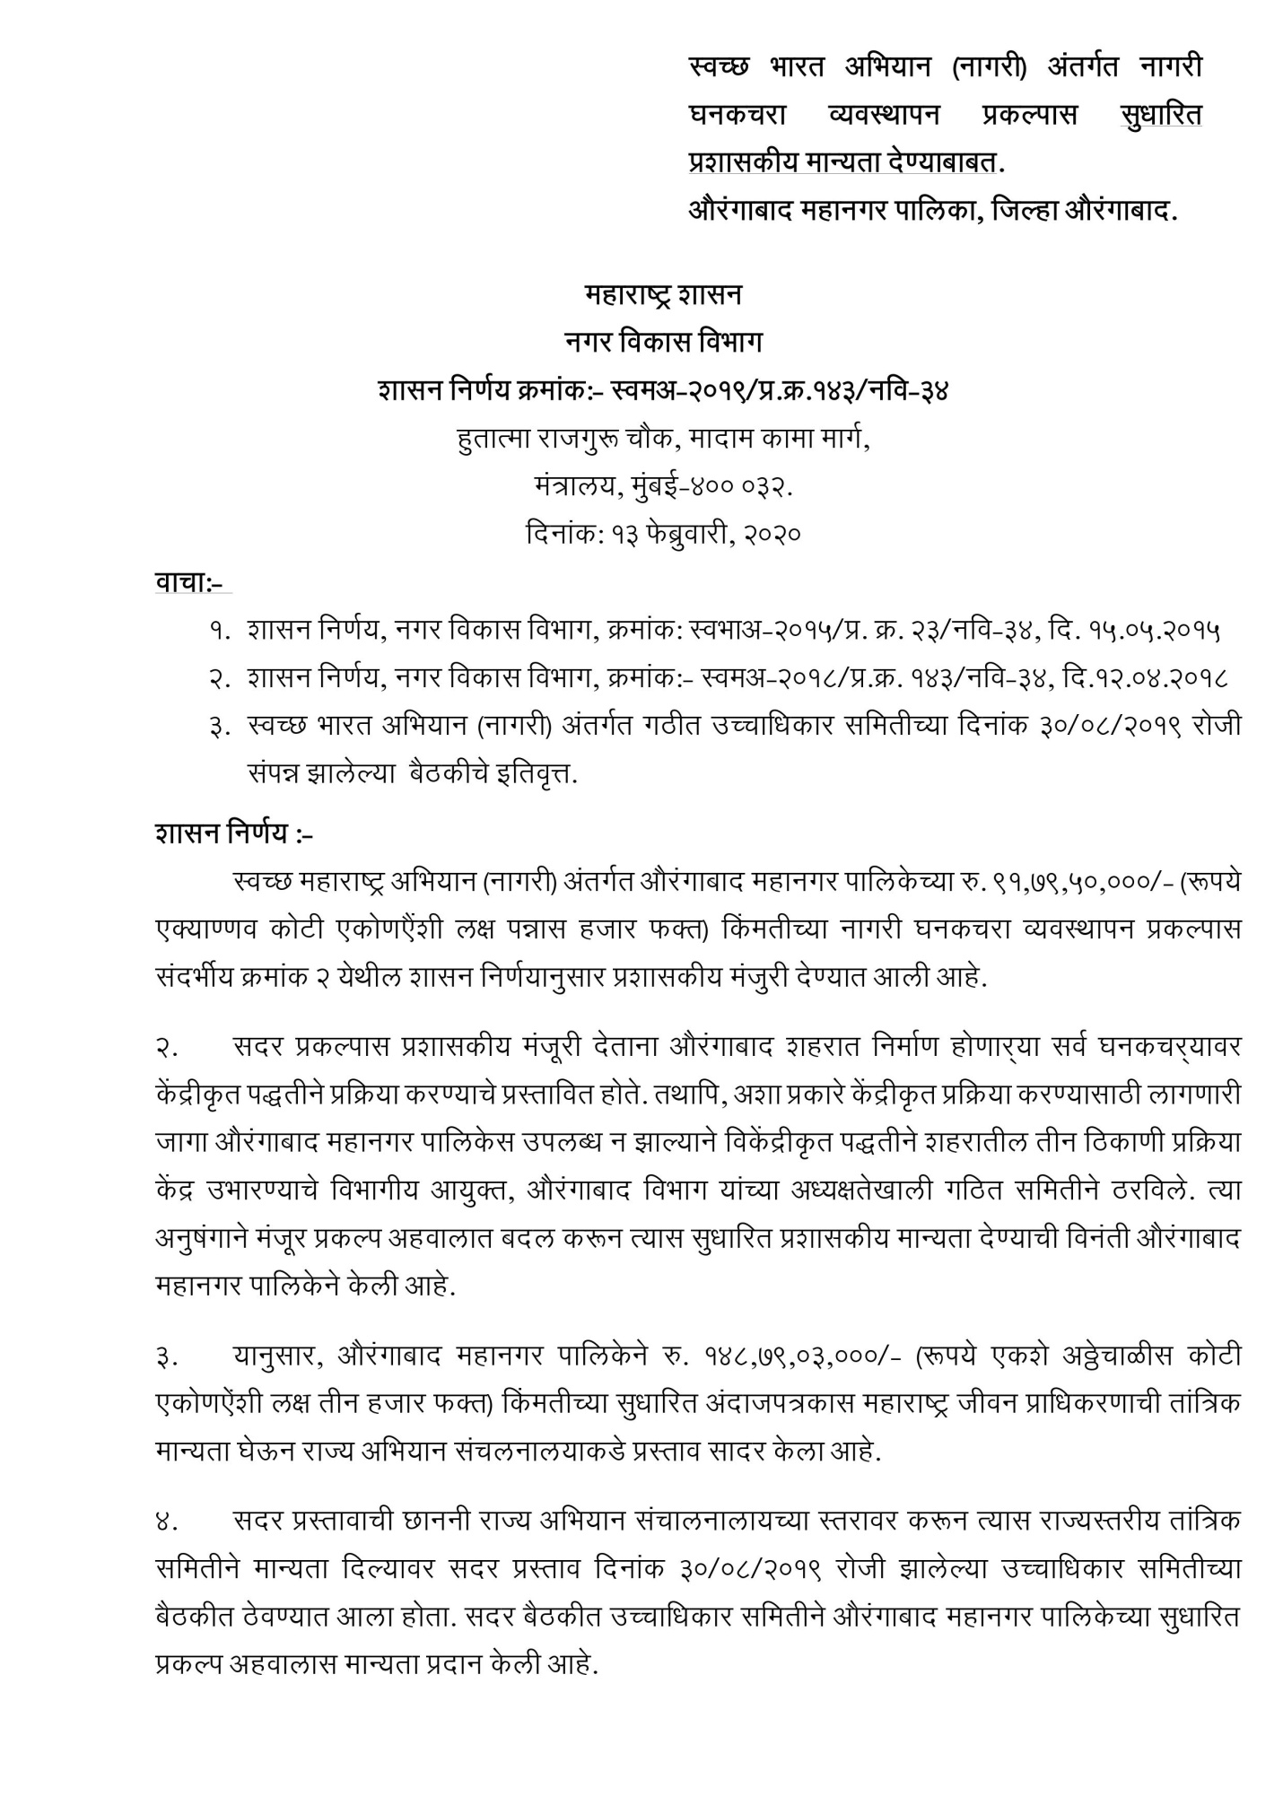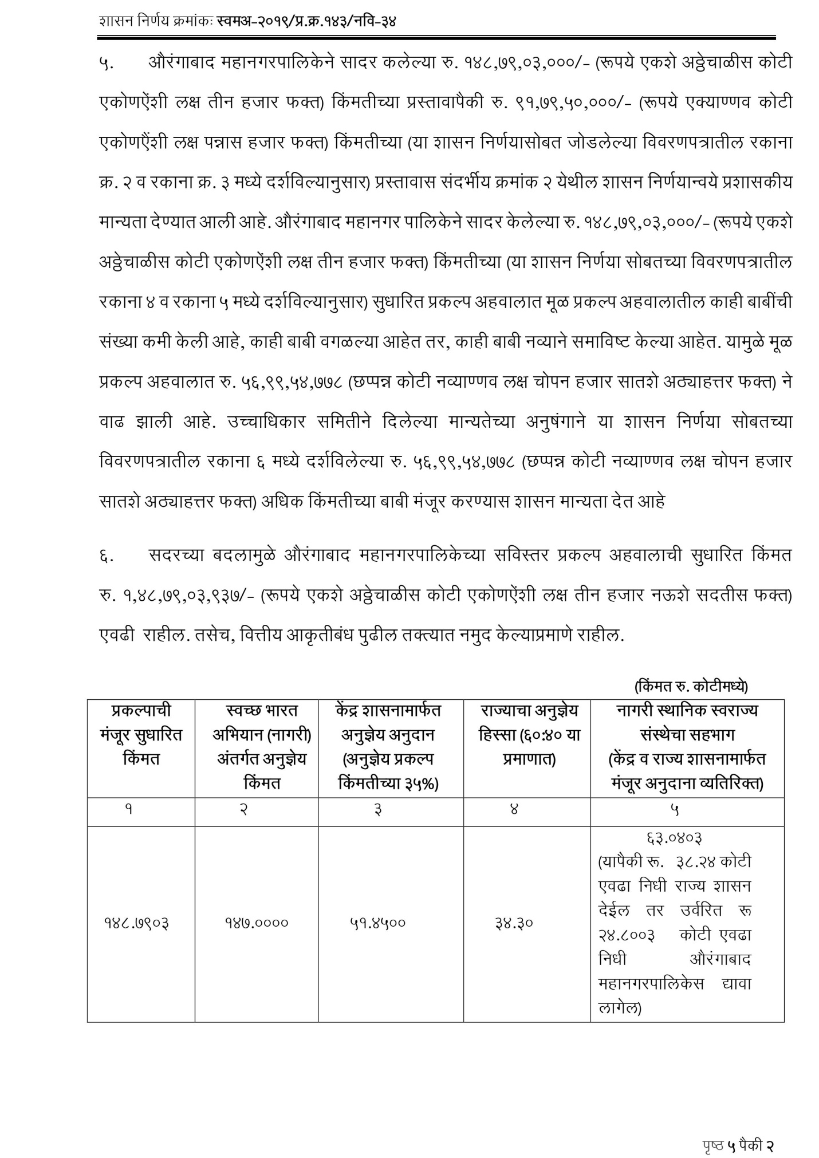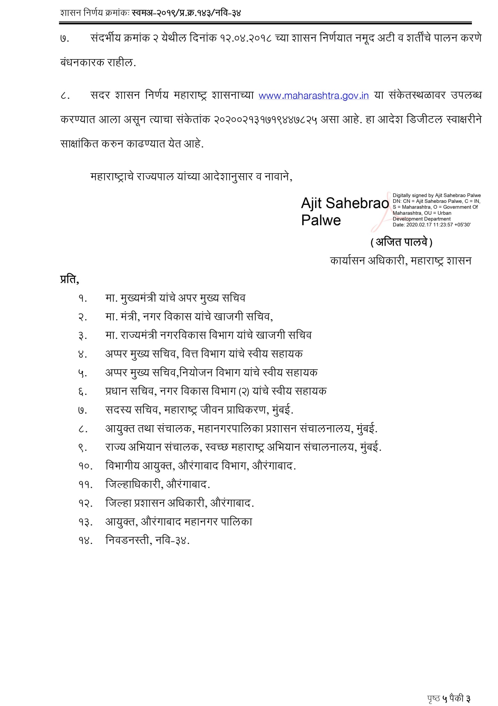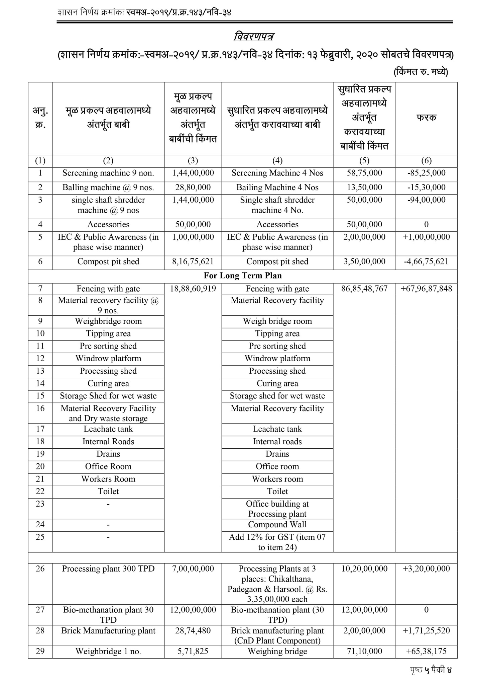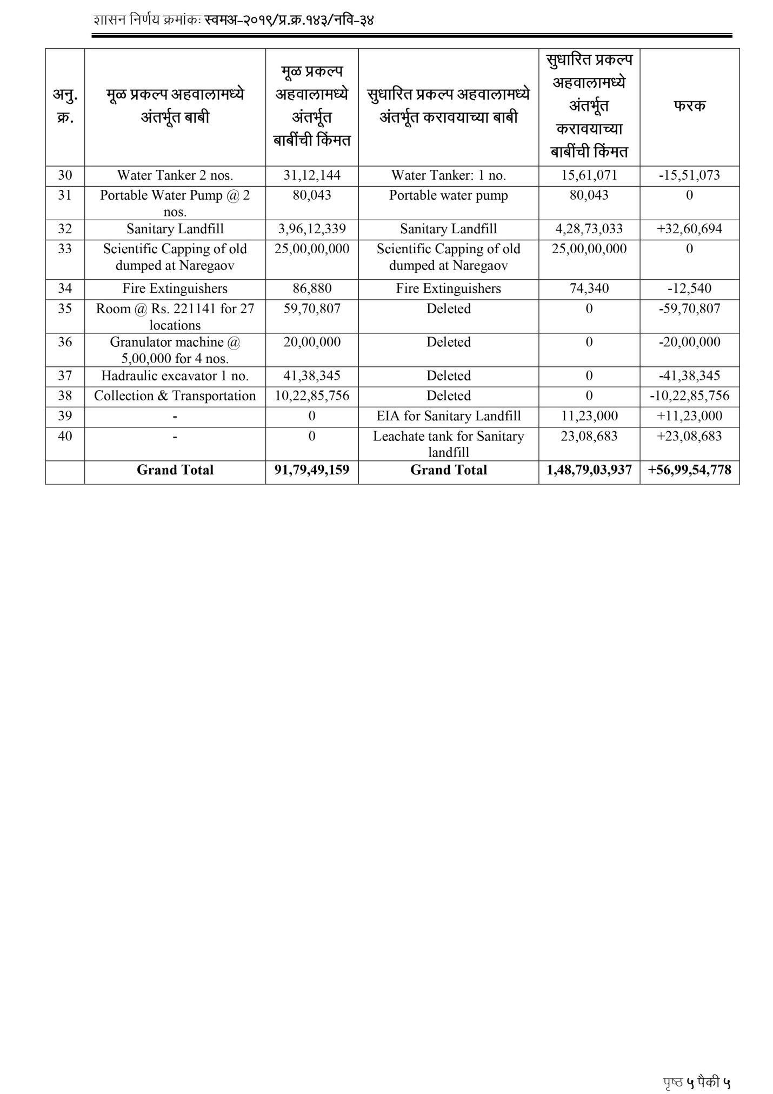

3.6 Overall Compliance of SWM Rules
There are several rules and regulation which have been formulated pertaining to SWM. Relevant ones for Aurangabad are:
3.7 Salient features of MSW Rules, 2016
These rules apply to every ULB, outgrowths in urban agglomerations, and the census towns, notified areas, notified industrial townships, areas under the control of Indian Railways, airports, airbases, Ports and harbours, defence establishments, special economic zones, State and Central government organisations, places of pilgrims, religious and historical importance as may be notified by respective State government. The main highlights of the Rule are:
• The waste generator should segregate and store the waste in three separate streams i.e. bio-degradable, non-biodegradable and domestic hazardous wastes

• Store separately construction and demolition waste
• Waste generator cannot burn the waste
• The waste generators shall pay user fee for solid waste management
• All gated communities, institutions and RWAs shall ensure segregation of waste at source level

Key duties of the waste generators:
• Segregate, store and handover separately the waste generated by them in three separate streams namely bio-degradable or wet waste, non-bio- degradable or dry waste and domestic hazardous wastes. All gated communities, institutions and RWAs shall ensure segregation of waste at source level
• No waste generator shall throw the waste generated by him/her on the street, open spaces, drain or water bodies; or burn the waste in open
• Pay user fee or charge or fines as may be specified in the bye-laws of the urban local bodies

Key Duties of Commissioner or Director of Municipal Administration or Director of Local Bodies:
• Ensure implementation of MSW rules by all urban local bodies falling under his/her control.
• Undertake training and capacity building of urban local bodies for management of solid waste.
• Facilitate establishment of common regional sanitary landfill for a group of

cities and towns falling within a radial distance of fifty kilometres or more from the regional facility on a cost sharing basis and ensure professional management of such sanitary landfills.
Key Duties and Responsibilities of Urban Local Bodies:
• Prepare a solid waste management plan as per State Policy And Strategy on Solid Waste Management within six months from the date of notification of state policy
• Frame bye-laws, incorporating the provisions of these rules and ensure timely implementation.
• Prescribe and collect user fee from waste generators.
• Develop infrastructure for segregation, collection, transportation, storage, processing and disposal of solid waste in their respective jurisdiction either at its own or through public private partnership mode.
• Provide easy access to waste pickers and recyclers for collection of segregated recyclable waste.
• Facilitate construction, operation and maintenance of solid waste processing facilities and associated infrastructure in house or with private sector participation using best suited technologies.
• Undertake in house or through any other authorised agency, construction, operation and maintenance of Sanitary landfill
• Make adequate provision of funds for capital investments as well as operation and maintenance of solid waste management services in the annual budget

Close down, remediate wherever feasible and cap the existing dumpsites, which are not engineered landfill sites as per the provision of these Rules
• Prepare and submit annual report on the status of compliance of these rules during the calendar year on or before the 30th April of the succeeding year to the Commissioner or Director Municipal Administration
• Create public awareness through Information, Education and Communication (IEC) campaign
Key Duties of the Operator of Solid Waste Processing and Treatment Facilities:
Identification and notification of land for setting up the solid waste processing and treatment facilities shall be the responsibility of the ULB. However the criteria for setting up of solid waste processing and treatment facilities and key responsibilities of the operator are:
• Design and set up the facility as per the technical guidelines issued by the Central Pollution Control Board in this regard from time to time and the manual of Central Public Health and Environmental Engineering Organization, New Delhi
• Obtain the approval from the State Pollution Control Board or Pollution Control Committee
• Ensure safe and environmentally sound operations of the solid waste processing and treatment facility and its closure and post closure phase as per the guidelines issued by Central Pollution Control Board from time to time and the Manual of Central Public Health and Environmental Engineering Organization, New Delhi.
• Submit annual report in the prescribed form

Maharashtra Plastic Carry Bags (Manufacture and Usage) Rules, 2006
• Prohibition of usage of carry bags-trade of recycled plastics
• No vendor shall use carry bags or containers made of recycled plastics less than 50 microns for storing, carrying, dispensing, or packaging of foodstuffs.

Regulatory Aspects/Provision of MSW Landfills:
Under section 6 (3) of the SWM Rules, 2016 State Pollution Control Board or Pollution Control Committee shall issue authorization in Form-III to the municipal authority or an operator of a facility within forty-five days stipulating compliance criteria and standards as specified in Schedule II, III and IV including such other conditions, as may be necessary. SPCBs/PCCs, after the receipt of application from the municipal authority or the operator of a facility including landfills, shall examine the proposal taking into consideration the views of other agencies like the State Urban Development department, the Town and Country Planning department. Airport or Air Base authority, the ground Water Board or any such other Agency prior to issuing the authorization
Chapter 7. Institutional Aspects and Capacity Building
The subject of solid waste management has remained neglected for the past several decades with the result that the level of service is highly inadequate and inefficient. For improving the solid waste management services it is essential to adopt modern methods of waste management, having a proper choice of technology, which can work in the given area successfully. Simultaneously, measures must be taken for institutional strengthening and internal capacity building so that the efforts made can be sustained over a period of time and the system put in place can be well managed. Institutional strengthening can be done by adequately decentralizing the administration, delegating adequate powers at the decentralized level, by including professionals into the administration and providing adequate training to the existing staff. NGO/private sector participation also needs to be encouraged to make the SWM services competitive and efficient.
7.1 Proposed Organizational Set-up
7.1.1 Decentralization of Administration
In the ULB, the SWM services can be performed effectively only if its administration is adequately decentralized at the ward level and prabhag level.
The SWM functions are proposed to be decentralized as under:
7.1.2 Ward Level & Prabhag Level Administration
The ward level administration should be fully responsible for ensuring storage of segregated waste at source, primary collection of waste, street sweeping and taking the waste to bulk community waste storage sites clearing debris and cleaning surface drains and public spaces. The cleaning of each street, lane by lane, markets
Detailed Project Report for Solid Waste Management
Aurangabad Municipal Corporation, Maharashtra
75 | P a g e
S w a c h h M a h a r a s h t r a M i s s i o n
and public space should be regularly supervised by the ward level supervisors. The presence of all SWM officers of the ward in the field during and morning hours is most essential. A grievance redressal system should be put in place in each ward. Ward level efforts could be made in the following:
• Creating public awareness at the ward level
• Formation of Residents Association/ Neighbourhood Committees to ensure public participation in source segregation of recyclable waste and deposition of domestic waste in the handcarts on time during primary collection
• Involving school children to be watchdogs in preventing littering of streets by the people
• Interfacing with the people and officials and help in redressal of public grievances on SWM at the ward level
• Supporting the effort of cost recovery for the services rendered
• Encouraging NGO participation

7.1.3 City Level Administration
The city level administration should supervise and support the ward level administration. The SWM Department should be responsible for upkeep of vehicles, setting up and maintenance of processing plants as well as for managing the disposal sites in an environmentally acceptable manner.
The SWM department should also be responsible for the procurement of vehicles, equipment, and land for processing and disposal of waste. As a Head office it should take policy decisions and co-ordinate the activities of all the wards and be answerable to the chief executive officer and elected body for the efficient functioning of the department. It should look after the recruitment of manpower, human resources development and training, etc.
7.2 Training & Capacity Building
Human resources development is very essential for internal capacity building for any organization. Training, motivation, incentives for outstanding service and disincentives for those who fail to perform are essential for human resources development.
Concerted efforts should be made by the Municipal Council to inculcate among its officers and staff a sense of pride in the work they do and to motivate them to perform and give their optimum output to improve the level of services of the city and the image of the Municipal Council.
7.2.1 Special Training to Unqualified Staff
Unqualified supervisory staff should be given service training to qualify for supervising sanitation works.
Detailed Project Report for Solid Waste Management
Aurangabad Municipal Corporation, Maharashtra
76 | P a g e
S w a c h h M a h a r a s h t r a M i s s i o n
7.2.2 Refresher Courses for Supervisory Staff
Refresher courses should be conducted for the supervisory staff at least every 5 years or they should be sent for training to get an exposure to advance in this field.
7.2.3 Work Norms
The sweepers may be assigned “Pin point” individual work assignments to the density of the area to be swept.
Similarly work norms may be prescribed for variety of vehicles used depending upon the distance to be travelled and the places to be covered. These norms may be prescribed after conducting time and motion study.
The norms of work for the supervisor may also be prescribed and monitored by the Municipal Council, for the extent of sweeping areas and the number of garbage collection points to be inspected watch day by the various levels of supervisors and inspection of processing and disposal sites etc. to ensure adequate output of the supervisory staff.
For capacity building of the department, senior officials should be frequently exposed to developments taking place in various parts of the State and Country by sending them out on city visits and to attend seminars, workshops and training courses. They should also be involved in all decision-making processes
7.2.4 Course Content for Training to Staff/Officers
A. Training to sanitation workers
1 Importance of sanitation in urban areas.
2 Present scenario of solid waste management system in the urban areas, deficiency in the system etc.
3 Impact of inefficient SWM services on health and environment
4 Impact of inefficient SWM services on the health of sanitation workers.
5 Inefficiency of tools and equipments used and loss of manpower productivity.
6 Need for modernization of solid waste management practices.
7 Options available for improving the services.
8 Advantages of using improved tools and equipments for primary collection of waste and street sweeping.
9 Need for synchronization of storage of waste of source, primary collection of

waste and waste storage depots.
10 Proper upkeep of tools and equipments and waste storage depots.

B. Training to Sanitation Supervisors of Various levels
1 to 10 as per A above
11 Need for synchronization of transportation of waste with waste storage depot. 12 Transportation of waste on day to day basis
13 Waste processing and disposal options, advantages and disadvantages of various technologies.

Detailed Project Report for Solid Waste Management
Aurangabad Municipal Corporation, Maharashtra
77 | P a g e
S w a c h h M a h a r a s h t r a M i s s i o n
14 Sanitary land filling.
15 Public and NGO participation in waste management. 16 Building public awareness.

17 Enforcement
C. Training for the officers looking after SWM Department
1 to 17 as per A & B above
18 SWM practices prevalent in other parts of the country and in the developed countries
19 Institutional strengthening, internal capacity building and human resource development.
20 Private sector participation in SWM 21 Management information system 22 Financial aspects
23 Health aspects
24 Legal aspects

D. Training modules of SBM
As a part of Swachh Bharat Mission (SBM) of GoI, an online e-portal has been created for training of municipal bodies. (https://swachhbharat.cloudapp.net). The portal draws from the leading practices in sanitation sector and introduces these to municipal functionaries who are at the forefront of delivering objectives of the Swachh Bharat Mission (SBM).
The various modules dwell into depth of each of the components of SBM and will be useful for officials of the state sanitation missions, city managers-engineers, administrators, field supervisors and sanitation workers in-charge of implementing SBM.
Successful completion will entitle the participant with a certificate from the Ministry of Urban Development, GoI. The ULB officials should be encouraged to complete the training modules of this portal.
The e-learning courses offered under this portal are as follows: i Municipal Solid Waste Management
ii Individual Household Toilets
iii Community and Public Toilets
iv IEC and Public Awareness Program v PPP and Financing Sanitation

vi Validated Sanitation Technologies
A certificate of completion is issued by the Ministry of Urban Development to the professional working in the government body, once the course is successfully completed.
Detailed Project Report for Solid Waste Management
Aurangabad Municipal Corporation, Maharashtra
78 | P a g e
S w a c h h M a h a r a s h t r a M i s s i o n
Chapter 8. Community Awareness and Public Participation
The success of any solid waste management scheme can be measured through the extent of co–operation of people, effectiveness of the proposed system and operational efficiency. While the effectiveness of the system and operational efficiency can be improved through HRD and capacity building, the co–operation of people can achieved through Information, Education and Communication (IEC) techniques. During such campaigns, strategies for waste reduction, Reuse and Recycling (R – & – R) may also be propagated for deriving long-term benefits.
8.1 Status of Public Participation in SWM
Solid waste management is not on the priority list for general public. The general approach to SWM has been ‘Out of Sight, Out of Mind’ and ‘Not in my backyard’ attitude. Community participation is not very active. Segregation of waste at source is not practiced religiously by all public. Waste is burnt in the open to get rid of the smell and junk. Public participation can be considered negligible when it comes to Solid Waste Management.
Waste is disposed off carelessly into the environment. The afterthought of waste processing is not considered. Thus, waste often ends up on fertile soil and water bodies contaminating our environment. There are cases where waste ends up in our drains and clogs the drain resulting in an ample amount of wastage of resources and energy.
Also, waste management is not considered as a dignified job and there is lack of leadership in taking the system of waste management to a higher level. Thus, there are many loopholes in the system that needs to be corrected and catered to.
8.2 Essential Steps of Public Participation
The success of SWM depends on building meaningful partnership with the stakeholders. Active involvement of the following community groups is essential especially in primary collection:
 Resident Welfare Associations
 Hotel owners Association
 Hospital owners association
 Merchants union
 Diary owners association
 Builders (Building Contractors) Association

The ULB may organize the above groups through a series of interactive meetings with the office bearers before a phased programme for community awareness is launched.
Detailed Project Report for Solid Waste Management
Aurangabad Municipal Corporation, Maharashtra
79 | P a g e
S w a c h h M a h a r a s h t r a M i s s i o n
NGOs can provide support in:
 Awareness creation programmes
 In developing pilot programmes
 In organizing door – to – door collection systems
 In setting up local processing units

Community awareness programme have to focus on:
 Awareness of the perils of the present practice, their role in keeping the surroundings clean.
 Not to litter on streets
 Storage of waste at source in two bins in a segregated manner
 Primary collection from doorstep
 Popularizing 4R strategy – Reduce, Reuse, Recycle, Recovery
 Discourage use of plastics
 Developing methodology for reaching schools to create awareness among children

8.3 Public Information, Education, Communication Programs (IEC)
For the successful implementation of any program involving public at large in SWM system, it is essential to spell out clearly and make them known the manner in which local body proposes to tackle the problem of waste management and extent to which public participation in Solid Waste Management is expected to keep the city clean and improve the quality of life in the city.
Based on the recommendations by the various government agencies, and the SWM Rule, 2016, the approach to an IEC plan could be:
• Organize the safaimitra, train them for providing professional services in field of Solid Waste Management.
• Provide safaimitra training and other capacity development to guarantee efficient, quality and timely waste management services including door to door collection of waste.
• Mobilize resident communities and bring awareness to segregate the waste and not to throw or dump waste in back-lanes and open plots
• Execute Awareness and information campaigns, organize SBM thematic drives, meetings etc. as instructed by officials and Consultant
• Training of field staff of ULB in solid waste management and door to door collection, route rationalizing of vehicles and it’s planning and get it approved from officials and consultant.
• Awareness and training for segregation of waste at source to the citizens and staff of the ULB, organise meeting in consultation with Ward Corporator and RWA on weekly basis

Detailed Project Report for Solid Waste Management
Aurangabad Municipal Corporation, Maharashtra
80 | P a g e
S w a c h h M a h a r a s h t r a M i s s i o n
• Promote primary collection, secondary collection of waste and cleaning of entire ward area i.e. door to door collection in assign wards, collection and removal of road side waste dumps, collection and cleaning of waste bins, cleaning of drains and nallahs and cleaning of entire ward area and back- lanes.
• Identification of open defecation points in the wards, creating awareness

involving RWA, local residents, female groups, children and helping ULB to make the wards ODF, identification of locations for constructing new community /public toilets, suggest up gradation if required in existing community /public toilets. Filling up of application forms for constructing house hold toilets in the wards.
• Report weekly to the ULB officials and Consultant

